|  |
| --- |
| User Manual  Leave Approval(HRM & DM) |
| REFERENCE: GW/ERP/USER MANUAL |
|  |
| **Genweb2 Ltd.** |
| **10-Jul-17** |



|  |
| --- |
|  |

Contents

1. Leave Request Approval by Department Manager 3

1.1 Leave Summary 3

1.2 First Approval Leave Request by Department manager 3

2. Leave Request Approval by HR Manager 5

2.1 Leave Summary 5

2.2 Final Approval Leave Request by HR Manager 5

3. Leave Allocation Request Approval by Department Manager 6

3.1 First Approval Leave Allocation Request by Department Manager 6

4. Leave Allocation Request Approval by HR Manager 7

4.1 Final Approval Leave Allocation Request by HR Manager 7

# 1. Leave Request Approval by Department Manager

## 1.1 Leave Summary

Department manager can see all of employee leave Summary.

Using the menu **Leave ‣ My Leaves ‣ Leave Summary**.

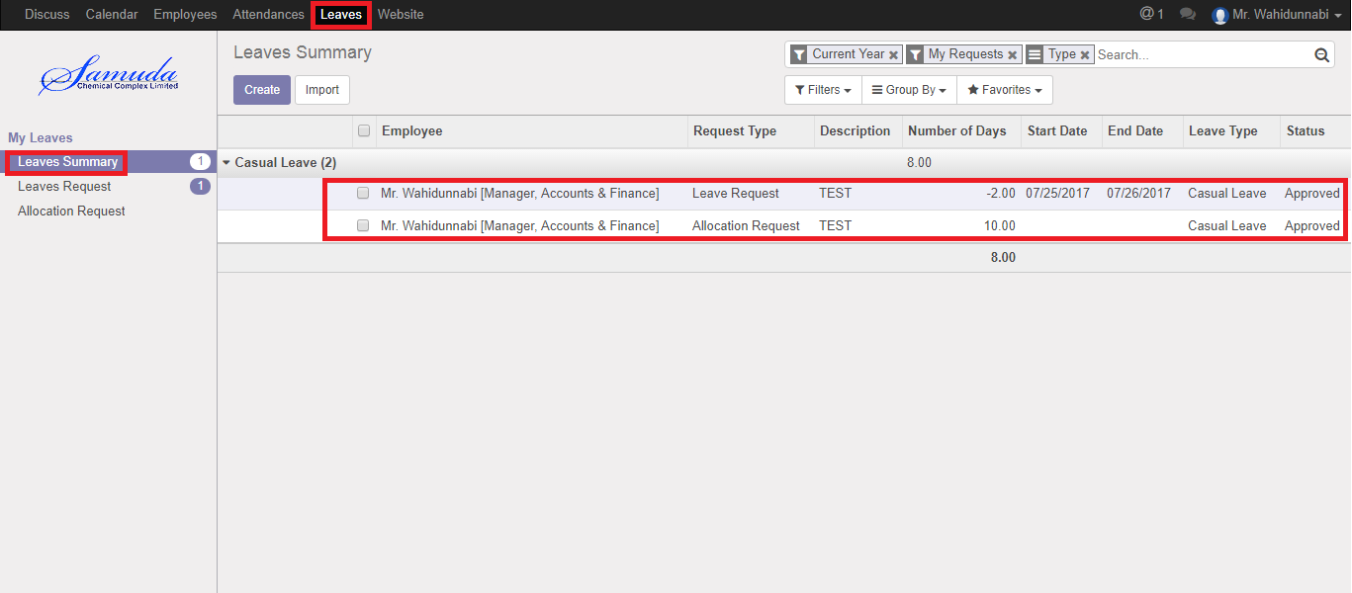

Figure: Leave Summary

## 1.2 First Approval Leave Request by Department manager

After apply the leave request “Department Manager” will get the notification. Department Manager can first approve the leave request. Department Management can update number of leave day(s) before approve. After Department Manager Approval, HR will get notification.

To see the employee leave request use the menu **Leave ‣ My Leaves ‣ Leaves Request.**

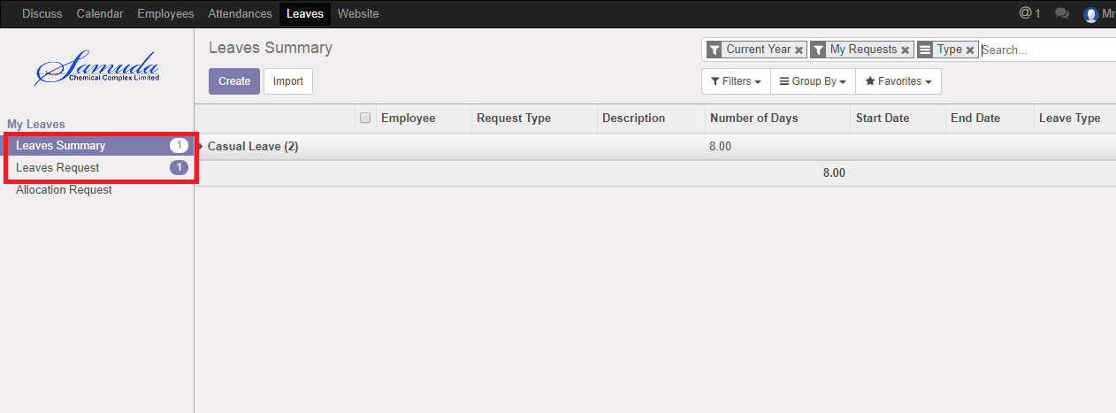

Figure: Leave Request Notification

Department manager can approve employee’s leave request. Department Manager can see all leave request there **Leave ‣ Leave to approve ‣ Leaves.**

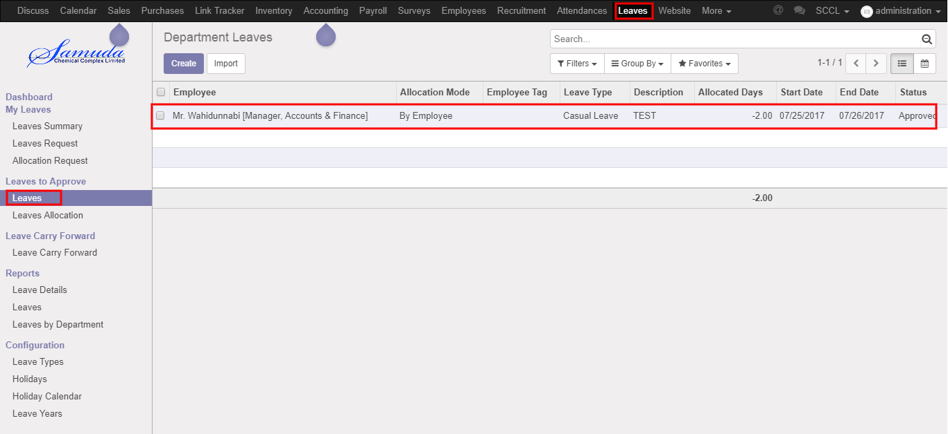

Figure: Leave Request List View

Here Department Manager can first approve the leave request by click on **Approve** button. He can update number of leave day(s) before approval.

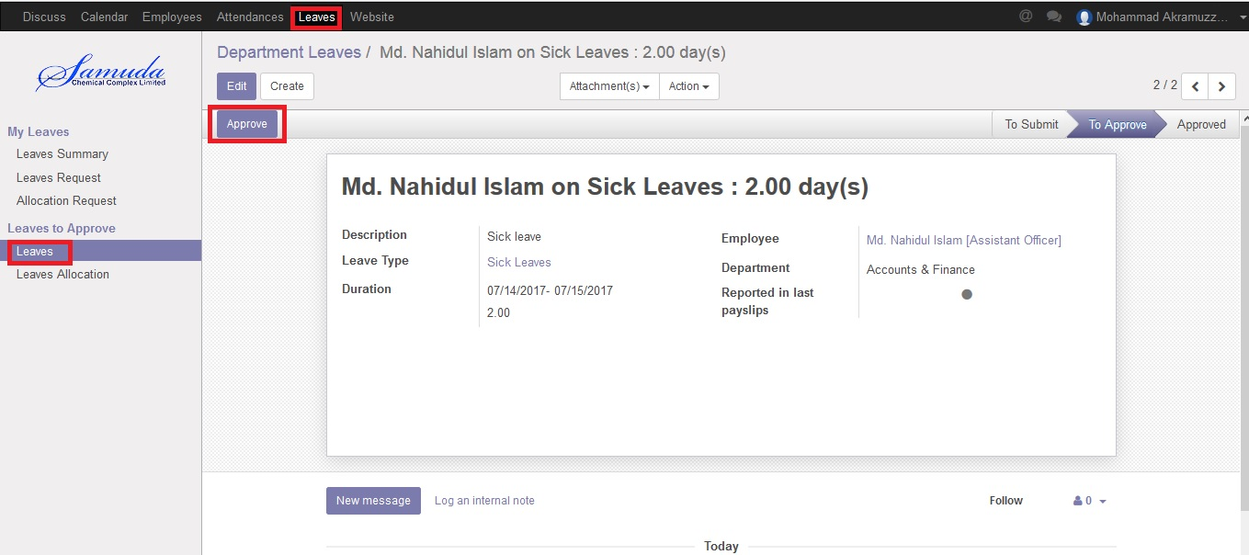

Figure: A Leave Request First Approval

Department Manager can refuse leave request by click **Refuse** Button.

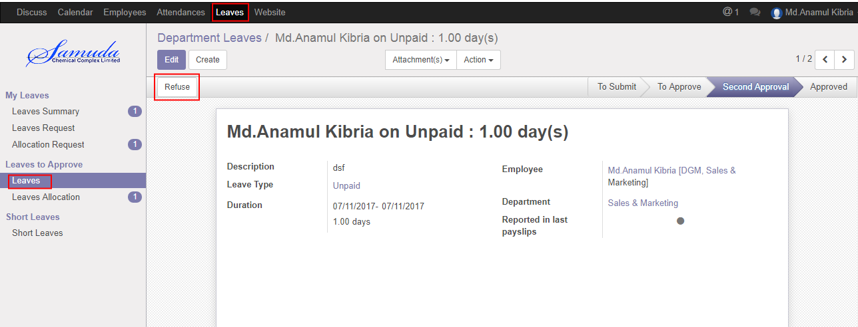

Figure: A Leave Request Refuse

# 2. Leave Request Approval by HR Manager

## 2.1 Leave Summary

HR Manager can see all of employee leave Summary.

Using the menu **Leave ‣ My Leaves ‣ Leave Summary**.



Figure: Leave Summary

## 2.2 Final Approval Leave Request by HR Manager

After Department manager’s first approval, HR manager can final approve or refuse the employee’s leave request. HRM can see all leave request there **Leave ‣ Leave to approve ‣ Leaves.**

Here HR Manager can final approve the leave request by click on **Validate** button.

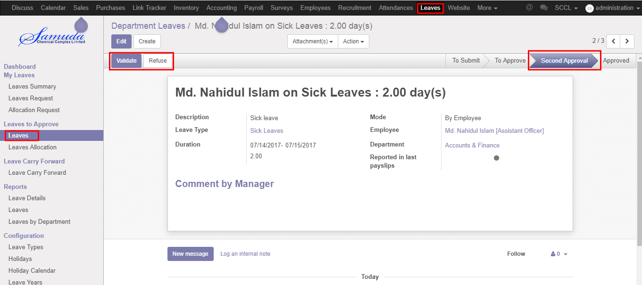

Figure: A Leave Request Second Approval

# 3. Leave Allocation Request Approval by Department Manager

## 3.1 First Approval Leave Allocation Request by Department Manager

After apply the leave allocation request “Department Manager” will get the notification. Department Management can update number of leave day(s) before approval. After Department Manager Approval, HR will get notification.

Here Department Manager can first approve the leave allocation request by click on **Approve** button.

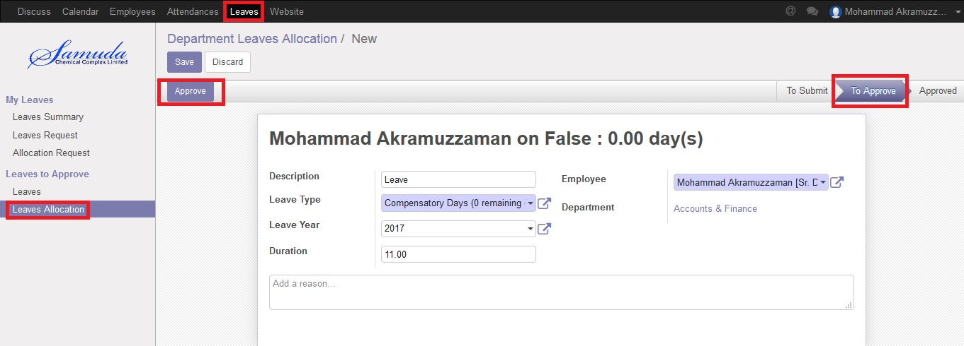

Figure: Leave Allocation Request First Approval

# 4. Leave Allocation Request Approval by HR Manager

## 4.1 Final Approval Leave Allocation Request by HR Manager

After apply the leave allocation request “HR Manager” will get the notification. After first approval the leave allocation request by Department Manager, HR Manager will get notification. HR Manager Can Approve or Refuse the leave allocation request. After that requested leave will finally approve.

Here HR Manager can final approve the leave request by click on **Validate** button.

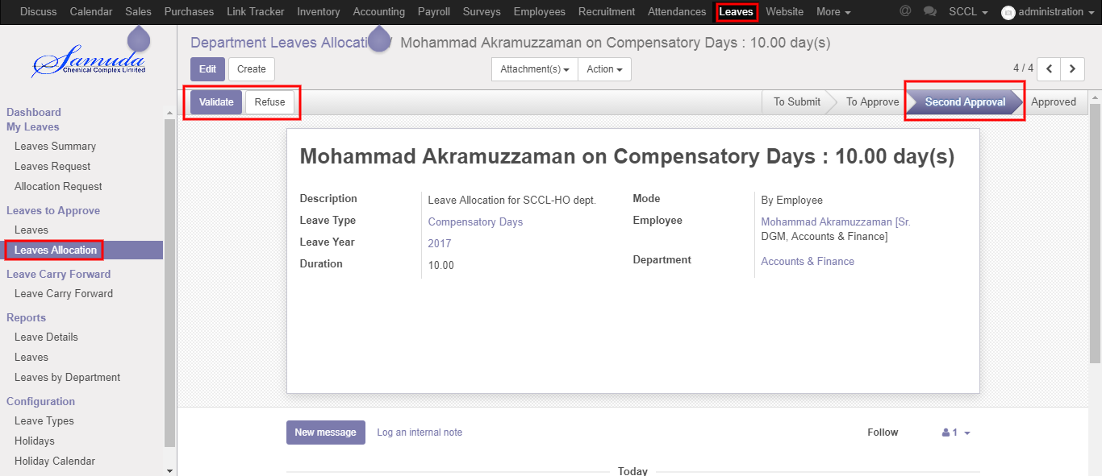

Figure: Leave Allocation Request Second Approval